**ALL ABOUT JHARKHNAD**

**An Android Application**

*A minor Project Report submitted in partial fulfillment of the degree of*

**Bachelor of Engineering**

By

Shashi Jaiswal

(BE/6116/14)

**Under the supervision of Mrs. Neena Jha**



**DEPARTMENT OF COMPUTER SCIENCE AND ENGINEERING**

**BIRLA INSTITUTE OF TECHNOLOGY MESRA**

**(November 2017)**

**CERTIFICATE**

It is certified that the work contained in the project report titled **“All About Jharkhand - An android application”** by **“Shashi Jaiswal”** has been carried out under my supervision and that this work has not been submitted elsewhere for a degree.

***Signature of Supervisor***

Neena Jha

B.I.T. Mesra

Off Campus Deoghar

(November 2017)

**DECLARATION**

I declare that this written submission represents my ideas in my own words and where others ideas or words have been included, I have adequately cited and referenced the original sources. I also declare that I have adhered to all principles of academic honesty and integrity and have not misrepresented or fabricated or falsified any idea/data/fact/source in my submission.

I understand that any violation of the above will be cause for disciplinary action by the Institute and can also evoke penal action from the sources which have thus not been properly cited or from whom proper permission has not been taken when needed.

(Signature)

SHASHI JAISWAL

(BE/6116/14)

Date: 23 Nov. 2017

**APPROVAL SHEET**

This project report entitled “**All about Jharkhand - An android application”** by **“Shashi Jaiswal”** is approved for the degree of *Bachelor of Engineering.*

**Supervisor**

Mrs. Neena Jha

**Date:**______________

**Place**:­­______________

ACKNOWLEDGEMENT

It gives us immense pleasure to express our deepest sense of gratitude and sincere thanks to our highly respected and esteemed guide Mrs. Neena, faculty in department of CSE, Birla Institute of Technology , Mesra, Deoghar campus, for their valuable guidance, encouragement and help for completing this work.

Their useful suggestions for this whole work and co-operative behavior are sincerely acknowledged.

Last but not the least I would like to extend my heartiest thanks to our family for their unconditional love and constant moral support.

**Shashi Jaiswal**

**(BE/6116/14)**

**ABSTRACT**

All About Jharkhand is one in all app to facilitate its user about the rich heritage of Jharkhand. It provides information about various sectors of Jharkhand like Population Growth of districts, Tourist places to visit, Literacy Rate, Gender ratio and list of Drought prone districts.

The app is based on database linked to a web based server of government from where useful Information is extracted and presented to users. A new user can also register through the app can give his feedback to government. He may also ask query related to the app. It also provides Weather details of places where user wish to visit

The user is allowed to view the news of his city and can also view news according to his choice of place which he/she can choose in the option. Different sources of news will be updated according to User’s feedback and choice. User can report any news which he feels irrelevant and inappropriate.

**INDEX**

**1. Introduction**

1.1 Background…………………………………….……………………..…. 8

1.2 Concept………………………………………………………………….. 9

1.3 Scope …………………………………………….…………………….... 9

1.4 Advantage…………………………………………….………………….10

1.5 Disadvantage…………………………………………….……………….10

**2. Literature Review**

2.1 Android Introduction……………………………………….………...…..11

2.2 What is android…………………………………………….….....……….11

2.3 Android architecture……………………………………..…..……...........12

2.4 Android Lifecycle …………………………………..……………….…...13

2.5 Android building blocks…………………………………………..….…..14

2.6 PHP overview……………………………………………………..….......15

2.7 What exactly PHP do……………………………………………..…....…15

**3. System design and software components**

3.1 System overview…………………………………………………..…….16

3.2 Activity diagram…………….………………………………………….. 18

3.3 Use case diagram ………………..………………………………………19

3.4 Features available………….…….…………………...….........................20

3.5 Operating environment……………………………………………..…....21

3.6 Developers requirements…………….………..………………….….......21

3.7 Constraints………………………………………………….....................21

3.8 Assumption and depndencies……………………………..…....………..21

**4. Output screen**

4.1 Screenshots………………………………………………..……………. 23

4.2 Software engineering and paradigm applied…………………………….34

**5. Conclusion and scope…………………………………………………….35**

**6. References…………………………………………………………….......36**

**Chapter 1: INTRODUCTION**

**1.1 A little background**

Historically, developers, generally coding in low-level C or C++, have needed to understand the specific hardware they were coding for, typically a single device or possibly a range of devices from a

single manufacturer. As hardware technology and mobile Internet access has advanced, this closed approach has become outmoded.

In more recent years, the biggest advance in mobile phone development was the introduction of Javahosted MIDlets. MIDlets are executed on a Java virtual machine (JVM), a process that abstracts the underlying hardware and lets developers create applications that run on the wide variety of devices that support the Java run time. Unfortunately, this convenience comes at the price of restricted access to the device hardware.

In current scenario Android is the first truly open and comprehensive platform for mobile devices. It includes an operating system, user-interface and applications — all of the software to run a mobile phone but without the proprietary obstacles that have hindered mobile innovation.

**1.2 Concept**

This application works on any low end android device having android version 5.0 (JellyBean). The basic concept of this application is to fetch news from RSS feed of various news providers channel.

RSS feed will be provided in the form of XML file and we convert that XML feed into JSON input using a web script converter RSS2Json.com.

After converting it into JSON we can scrap it into human readable format and pest it onto card provided from CardView.

For posting photo from gallery I have used Base64 decoder to convert it into uploadable form. At server side I am storing only link of the image and storing it into another folder for convince of retrieving.

For showing image into card view I have used Piccasso Image View to implement it and to simplify it to visible image.

**1.3 Scope**

The scope of this project is to design an simple, efficient, light weight, user-friendly and socially related android news reader.

In current scenario there isn’t any such type of app which provide the facility of Blind support and Individual user as a reporter feature.

Since this is a new concept so there could be an entrepreneurship startup associated with this idea.

In the first part of the project I have focused on fetching location of user using GeoCoder class of android to provide him/her location based news.

In the second part of the project I have focused on fetching news from XML file. For each item tag there will be some news, link, image, publishing date and many more information. I have retrieved it and implemented it using Adapter on each Card.

In 3rd and unique part of project I have focused on inserting news from user’s side and fetching it by converting into JSON.

In 4th and last part of project I have focused on making UI more comfortable and user friendly. For this purpose I have used many animation of android and added custom fonts .

* 1. **Advantage**
* The app helps to empower people to give their view to government.
* The app provides news about Jharkhand.
* Quiz section in app helps to know little details about state.
* The location feature will help to know current and nearby location.

**1.5 Disadvantages**

* This app has been upgraded to higher versions so it may not run smoothly in lower version mobile.
* The size of app is little bit large.

**Chapter 2: LITERATURE REVIEW**

**2.1 Android Introduction**

In this section we will see about basic features of android, how it works, what its functionalities are and how we can implement it.

**2.2 What is Android?**

Android is a software package and Linux based operating system for mobile devices such as tablet computers and smartphones.

It is developed by Google and later the OHA (Open Handset Alliance). Java language is mainly used to write the android code even though other languages can be used.

The goal of android project is to create a successful real-world product that improves the mobile experience for end users.

There are many code names of android such as Lollipop, Kitkat, Jelly Bean, Ice cream Sandwich, Froyo, Ecliar, Donut etc.

Google’s Andy Rubin describes Android as follows:

“The first truly open and comprehensive platform for mobile devices. It includes an operating system, user-interface and applications — all of the software to run a mobile phone but without the proprietary obstacles that have hindered mobile innovation.”

Android's default user interface is mainly based on direct manipulation, using touch inputs that loosely correspond to real-world actions, like swiping, tapping, pinching, and reverse pinching to manipulate on-screen objects, along with a virtual keyboard.[64] Game controllers and full-size physical keyboards are supported via Bluetooth or USB.[65][66] The response to user input is designed to be immediate and provides a fluid touch interface, often using the vibration capabilities of the device to provide haptic feedback to the user. Internal hardware, such as accelerometers, gyroscopes and proximity sensors are used by some applications to respond to additional user actions, for example adjusting the screen from portrait to landscape depending on how the device is oriented,[67] or allowing the user to steer a vehicle in a racing game by rotating the device, simulating control of a steering wheel.

**2.3 Android architecture**

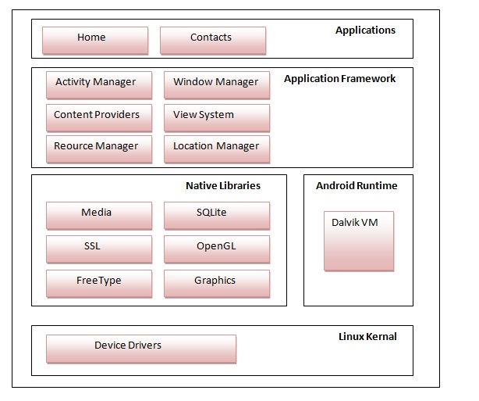

Android OS have following layers of operation fundamentals.

* Linux Kernal
* Native Libraries
* Android Runtime
* Application Framework
* Application

Above all of these user only interact with Application layer.

**2.4 Android Life Cycle**

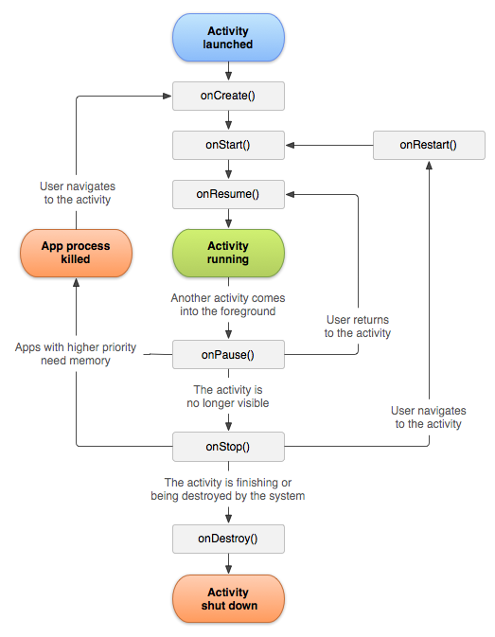

**2.5 Android Building Blocks**

Android have following building blocks:

1. **View**

A view is the UI element such as button, label, text field etc. Anything that you see is a view.

1. **Intent**

Intent is used to invoke components. It is mainly used to:

* Start the service
* Launch an activity
* Display a web page
* Display a list of contacts
* Broadcast a message
* Dial a phone call etc

1. **Services**

Service is a background process that can run for a long time.

There are two types of services local and remote. Local service is accessed from within the application whereas remote service is accessed remotely from other applications running on the same device.

1. **Content Providers**

Content Providers are used to share data between the applications.

1. **Fragments**

Fragments are like parts of activity. An activity can display one or more fragments on the screen at the same time**.**

1. **AndroidManifest.xml**

It contains informations about activities, content providers, permissions etc. It is like the web.xml file in Java EE.

**7.Android Virtual Device (AVD)**

It is used to test the android application without the need for mobile or tablet etc. It can be created in different configurations to emulate different types of real devices.

**2.6 PHP Overview**

PHP is an acronym for "PHP: Hypertext Preprocessor".

PHP works on the Server Side (on the server hosting the website). A single PHP file is like using magic on a webpage. In HTML, you have a standard page that is sent to anyone that visits your website. With PHP, you can dynamically change the page based on each individual user.

**2.6.1 What exactly does PHP do?**

* It can create custom content based on different variables
* It is excellent at tracking user information
* It can write or read information to databases, if partnered with a database language
* It can run on any type of platform and servers
* It can do anything a standard HTML file can and much more
* PHP can collect form data
* PHP can send and receive cookies
* PHP can add, delete, modify data in your database
* PHP can be used to control user-access
* PHP can encrypt data

**Chapter 3: System Design and Components**

**3.1 System Overview**

**………………………………………………………………….**

In my project Data is being fetched from XML document and also from online database administrated by me.

I have used JSON for encoding data object and then retrieve it by JSON Decoder class present in android.

Item is the base class which stores all the data of each particular item.

<item>

<title>

<![CDATA[

Yogi Says Rahul Sat in Temple Like He Was Offering Namaaz, Omar Abdullah Schools Him

]]>

</title>

<link>

<![CDATA[

http://www.news18.com/news/politics/yogi-says-rahul-sat-in-temple-like-he-was-offering-namaaz-omar-abdullah-schools-him-1583877.html

]]>

</link>

<description>

<![CDATA[

<img src='http://img01.ibnlive.in/ibnlive/uploads/2017/09/Rahul-Gandhi-temple.jpg' width='90' height='62' />Former Jammu and Kashmir chief minister Omar Abdullah slammed Adityanath for mocking the Congress leader’s temple visits and accused him of lying to polarise voters.

]]>

</description>

<pubDate>Tuesday,November 21,2017 8:53 pm</pubDate>

<guid>

<![CDATA[

http://www.news18.com/news/politics/yogi-says-rahul-sat-in-temple-like-he-was-offering-namaaz-omar-abdullah-schools-him-1583877.html

]]>

</guid>

<copyright>News18.com</copyright>

<language>en-us</language>

</item>

*An Item of a XML Document*

In the above written code each news is placed within <item> tag.

<img src=”___”> holdes link of the image which is stored at Database of providing channel.

<pubDate> stores publishing date of that particular news.

<description> tag stores a brief description of news.

<link> tag stores the link of news, upon click on that link it will be redirected to provider’s website

<title> tag stores the title of current news

<item> within item tag everything is been written.

For converting it to JSON I have used an online API. RSS2JSON.com

**3.2 Data flow Diagram**

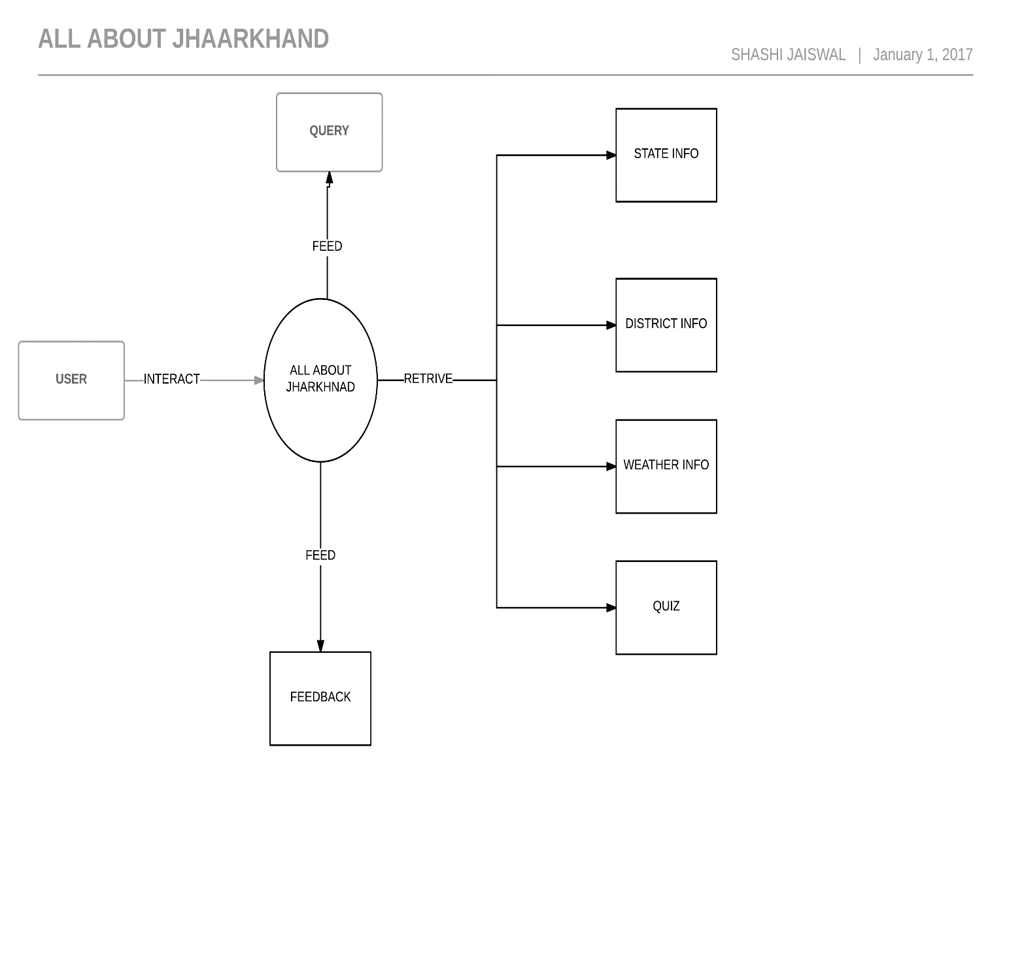

**Level - 0**

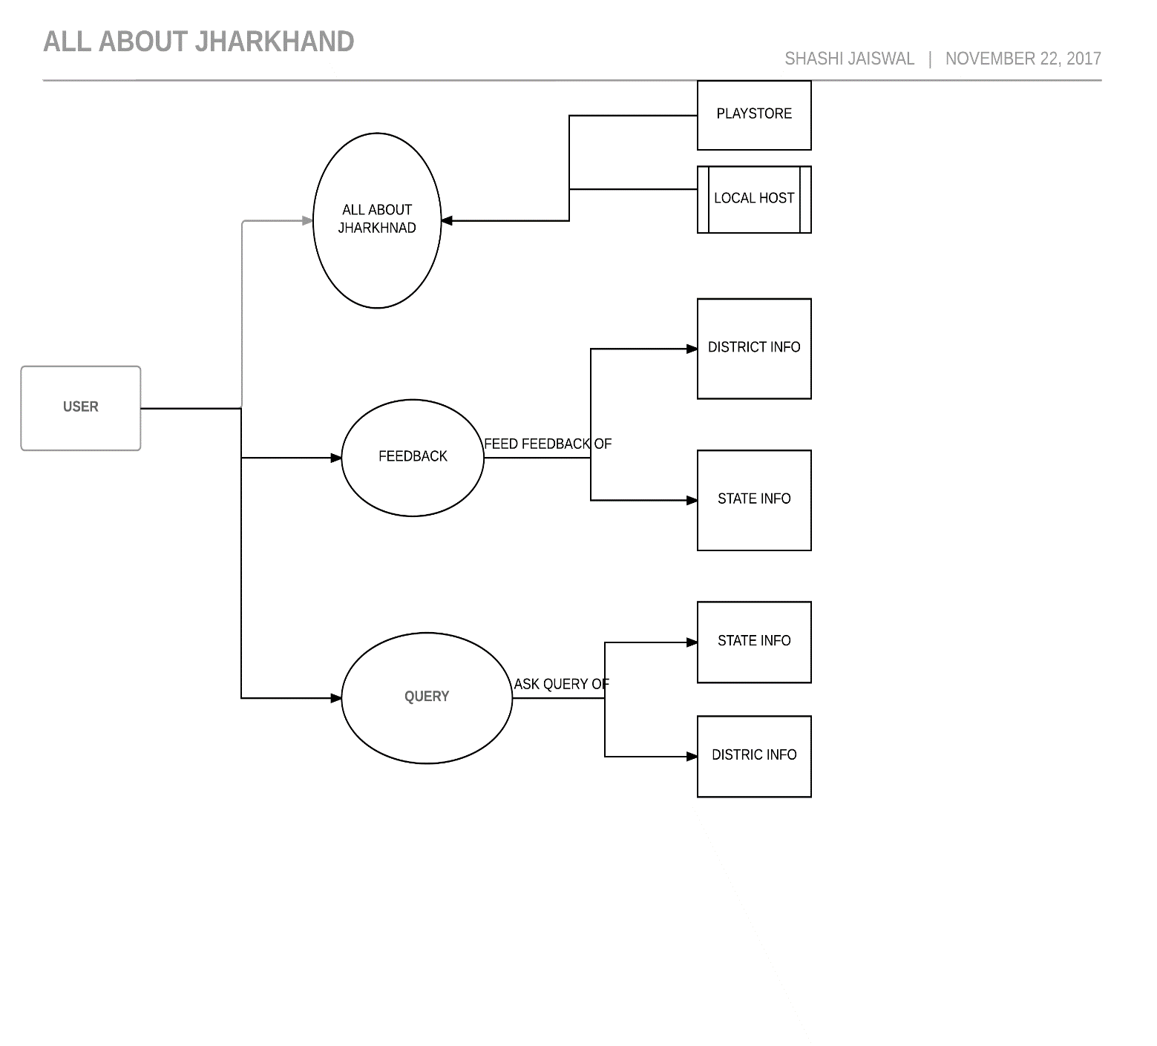

Level - 1

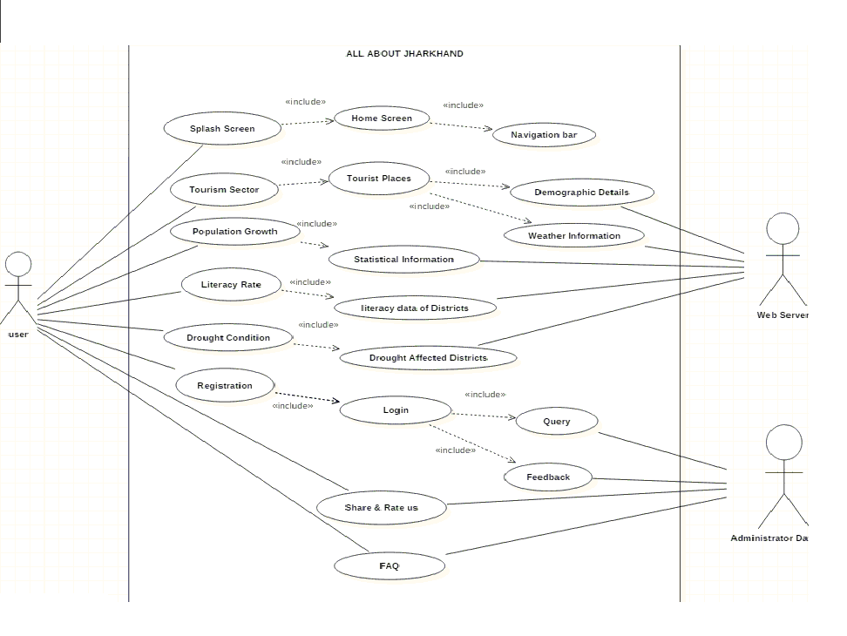**3.3 Use case Diagram**

**3.4 Features available to the users:**

* Can get details of state
* Can view news
* Can give feedback
* Can ask query
* Can play quiz
* Can get weather details
* And many more

**Features available to Administrator:**

* Can monitor feedback
* Can monitor query
* Make changes to database

**3.5 Operating Environment**

* Android Operating System
* Min android version 5.0
* Minimum RAM required 256 MB
* Maximum space required 100MB
* INTERNET Connectivity

**3.7 Developer’s Requirement**

* Android SDK
* JDK 8
* Android Studio
* PC with RAM higher than 4GB
* ACCESS_CORSE_LOCATION
* INTRNET_PERMISSION
* ACCESS_NETWORK_STATE
* ACCESS_DEVICE_STATE
* ACCESS_LOCATION_STATE

**3.8 Constraints**

* User must be aware of basic uses of Android device
* User must have basic knowledge of English

**3.9 Assumption and Dependencies**

For developing this project I have assumed that user have an active internet connection. And he knows to operate Mobile.

He has switched on GPS location.

**CHAPTER 4:**

**Output Screens**

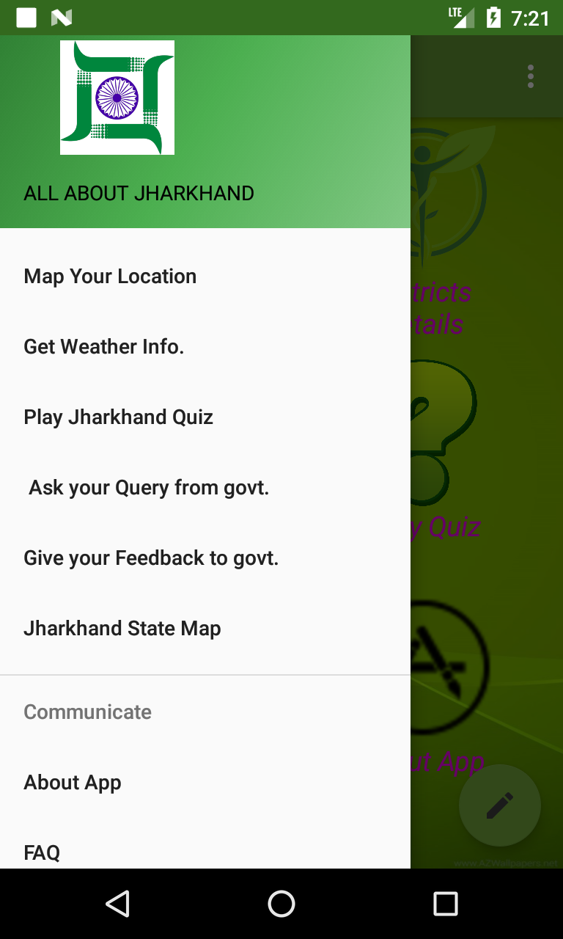

1. Home Screen

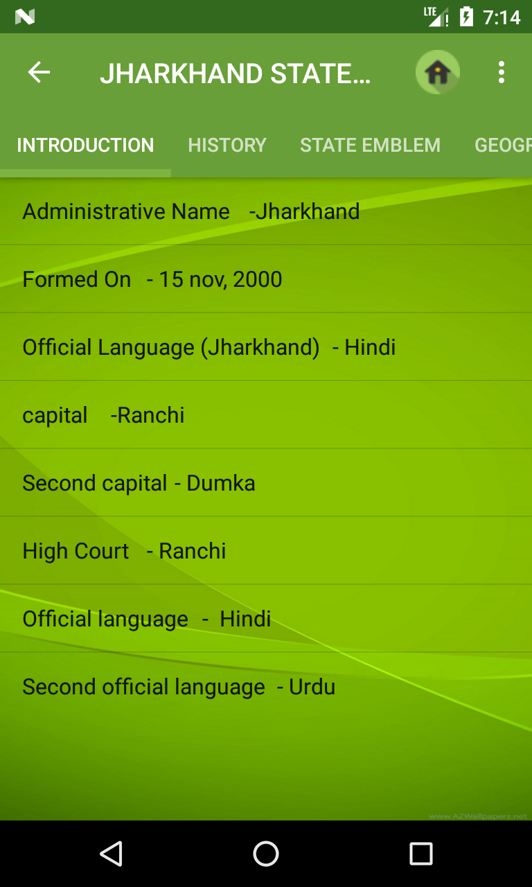

2. State Info

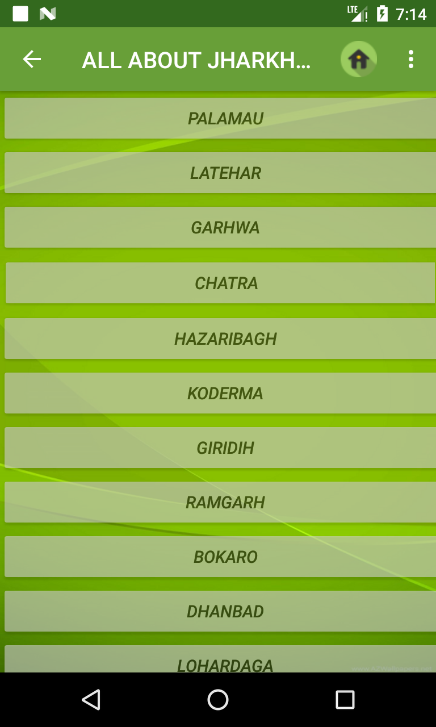

3. Districts wise information

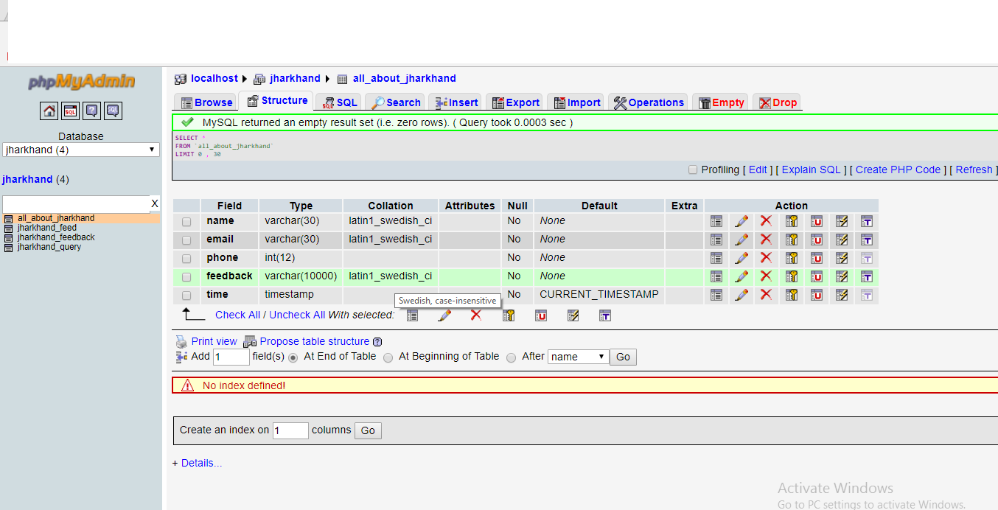

10. PHP MySQL Database

## 4.2 SOFTWARE ENGINERING PARADIGM APPLIED

* **Why prototype paradigm?**

Often, a customer defines a set of general objective for software but does not identify detail input, processing or output requirements. In other cases, the developer may be unsure of the efficiency of an algorithm, the adaptability of an operating system of the form that human/ machine interaction should take. In these, and many other situations, prototyping paradigm may offer the best approach.

The prototyping paradigm begins with requirement gathering. Developer and customer meet and define the overall objective for the software, identify whatever requirements are known and outlines areas. Where the further definition is mandatory. A “quick design focuses on a representation of those aspects of the software that will be visible to the customer/user (e.g. input approaches and output formats). The prototype is evaluated by the construction of a prototype. The prototype is evaluated by the customer/ user and used to redefine requirements for the software to be developed. Iteration occurs as the prototype is tuned to satisfy the needs of the customer, while same time enabling the developer to better understand what need is to be done. Ideally, the prototype serves as a mechanism of identifying software requirements. If a working prototype is built, the developer attempts to use existing program fragments of applies tools (e.g. report generation) that enable working programs to be generated quickly.

**Chapter 5:**

**CONCLUSION and SCOPE**

Android has been criticized for not being all open-source software despite what was announced by Google. Parts of the SDK are proprietary and closed source, and some believe this is so that Google can control the platform. Software installed by end-users must be written in Java, and will not have access to lower level device APIs. This provides end-users with less control over their phone's functionality than other free and open source phone platforms, such as OpenMoko.

With all upcoming applications and mobile services Google Android is stepping into the next level of Mobile Internet. Android participates in many of the successful open source projects. That is, architect the solution for participation and the developers will not only come but will play well together. This is notable contrast with Apple and other companies, where such architecture of participation is clearly belated.

The era of mobile technology opens the windows to the android app. The websites are vanishing and the smart phones are emerging it is time to change from conventional websites to apps which has become the pan of our daily routine. I am introducing the android application software which would easily facilitate knowledge. It works not only on small level but also it can work as a system.

**Chapter 6:**

**References**

The following books, journals and websites have played a crucial role for us in understanding and identifying the core of my project and methods to implement it:

*1)* http://jharkhandtourism*.gov.in (providing tourism details)*

2) http://jharkhandtourism.gov.in/feedback (for submitting feedback)

3) http://openweathermap.org/api/ (Weather API details)

4) [http://jharkhandtourism.gov.in/importantLink (other](http://jharkhandtourism.gov.in/importantLink%20%20(other) important link)

5) Advanced database and SQL by TANNEBAUM (5 edition.)